**LAB-3**

1.Create files under “UNIX” directory name “BCA” and “BBA” with duplicate records (student id, name, city, pincode, sem, DOB). Enter city “Bardoli” in more than 3 records. Enter duplicate records also. Date should be in dd/mm/yyyy format. Not Enter heading in file. See Below example.

EXAMPLE: 1| OM | BARDOLI | 394601 | 5 | 11/08/1992).

* ANS:

$ cat > BCA

$ cat > BBA

* OUTPUT:

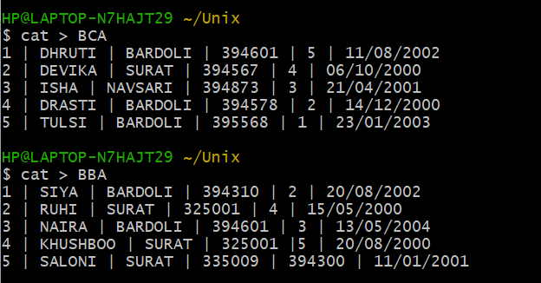

2.Write command to display first five lines from file “Intro” under “Web” directory.

* ANS:

$ head -n5 intro.txt

* OUTPUT:

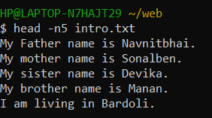

3. Display first 5 character of file "intro"..

* ANS:

$ head -c5 intro.txt

* OUTPUT:

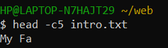

4. Count number of character from first five lines of file "Intro".

* ANS:

$ head -n5 intro.txt | wc -c

* OUTPUT:

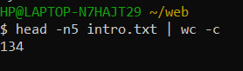

5. List 3 most recently used file in PWD.

* ANS:

$ ls -lt

* OUTPUT:

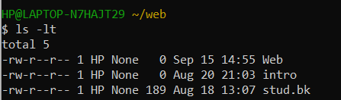

6. Display last five lines from file "Intro" under "Web" Directory.

* ANS:

$ tail -n5 intro.txt

* OUTPUT:

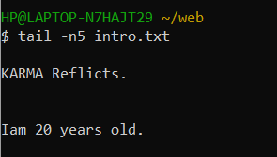

7. Count number of character in last line of "intro" file.

* ANS:

$ tail intro.txt | wc -c

* OUTPUT:

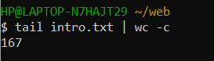

8. Display lines 4 to 9 from file "Intro".

* ANS:

$ head -9 intro.txt | tail +4

* OUTPUT:

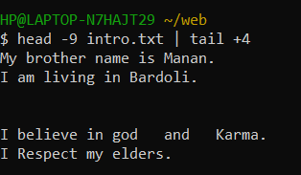

9. Display two lines starting from 7th line of file "intro".

* ANS:

$ head -n8 intro.txt | tail -2

* OUTPUT:

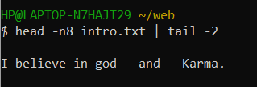

10. Count number of words in line 8 to 12 in file "intro".

* ANS:

$ head -n12 intro.txt | tail -5 | wc -c

* OUTPUT:

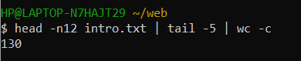

11. Display last five character of file "intro".

* ANS:

$ tail -c5 intro.txt

* OUTPUT:

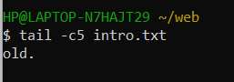

12. Display characters from 20th byte of "Intro".

* ANS:

$ tail -c+20 intro.txt

$ tail -c20 intro.txt

* OUTPUT:

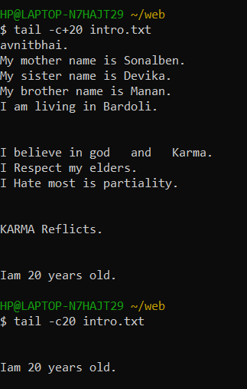

13. Display only 1st character of each lines.

ANS:

$ cut -c 1 intro.txt

* OUTPUT:

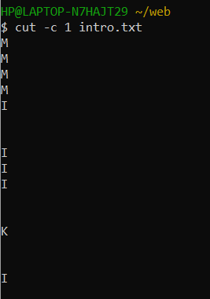

14. Display only 5 to 8 character of each lines.

* ANS:

$ cut -c 5,6,7,8 intro.txt

* OUTPUT:

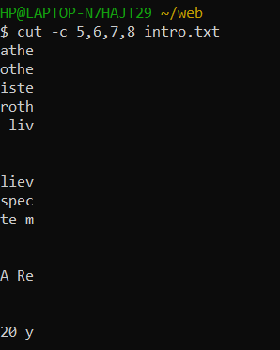

15. Display first 5 character of each lines.

* ANS:

$ cut -c -5 intro.txt

* OUTPUT:

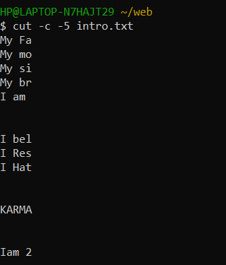

16. Display only 2nd field from "Stud" file of "Web".

* ANS:

$ cut -d “,” -f2 stud.bk

* OUTPUT:

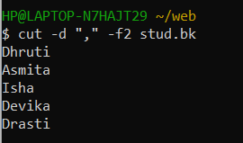

17. Display only 2nd to 3rd field from "Stud" file of "Web".

* ANS:

$ cut -d “,” -f2,3 stud.bk

* OUTPUT:

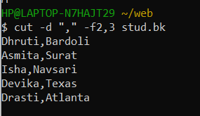

18. Display only 2,3, and 5 field form "Stud" file.

* ANS:

$ cut -d “,” -f2,3,5 stud.bk

* OUTPUT:

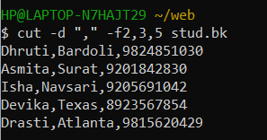

19. To Print field 2 to 5 from "stud" file.

* ANS:

$ cut -d “,” -f2-5 stud.bk

* OUTPUT:

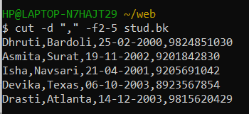

20. Merging two file "BCA" and "BBA" with delimiter ":".

* ANS:

$ paste -d ‘:’ BBA BCA

* OUTPUT:

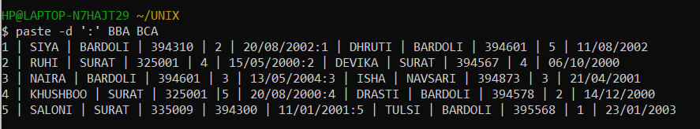

21. Sort File "BCA" .

* ANS:

$ sort BCA

* OUTPUT:

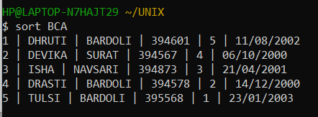

22. Sort File "BBA" and display only unique records. Use delimiter "|"

* ANS:

$ sort BBA | uniq

* OUTPUT:

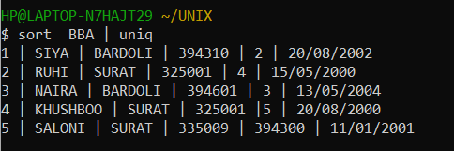

23. Sort File "BCA" on "ID" field.

* ANS:

$ sort -k1,1 BCA

* OUTPUT:

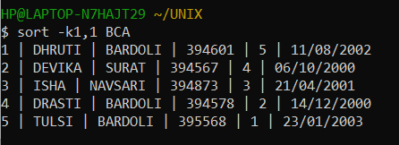

24. Sort file "BBA" on "Pincode" which is a numeric field in decending order.

* ANS:

$ sort -r -k4n,4 BBA

* OUTPUT:

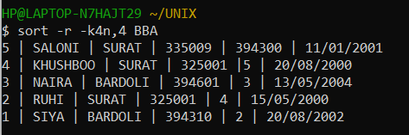

25. Sort file "BCA" on multiple field "ID" and "City" use delimiter ","

* ANS:

$ sort -t ‘|’ -k1n,3 BCA

* OUTPUT:

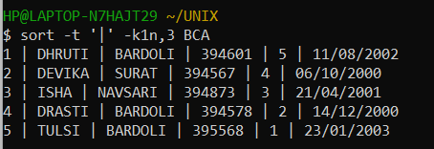

26. Sort file "BBA" on "Year of Birth" in ascending order with delimiter ":"

* ANS:

$

* OUTPUT:

27. Sort file by last access time.

* ANS:

$ ls -l | sort -k8 -k8.4,8.5n

* OUTPUT:

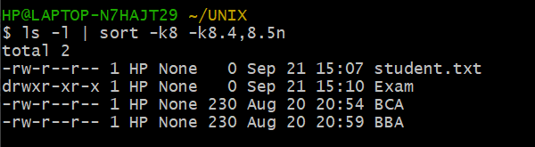

28. Display number of unique line in file "BCA".

* ANS:

$ uniq -c BCA

* OUTPUT:

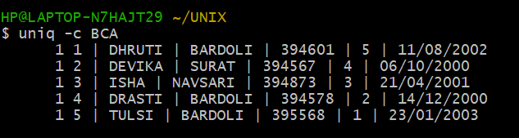

29. Display unique line from file "BCA".

* ANS:

$ uniq BCA

* OUTPUT:

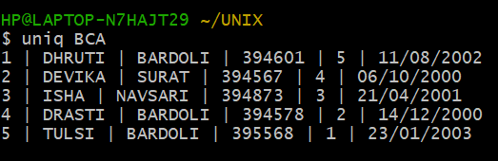

30. To remove duplicate line from a file “BBA”.

* ANS:

$ uniq -u BBA

* OUTPUT:

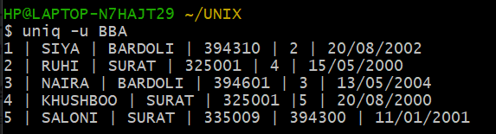

31. Display only duplicate line in file “BBA”.

* ANS:

$ uniq -d BBA

* OUTPUT:



32. Print frequency of each line from file “BCA”.

* ANS:

$ cat BCA | tr -s ‘ ‘ ‘\n’ | sort | uniq -c | awk ‘{print$2,$1}’

* OUTPUT:

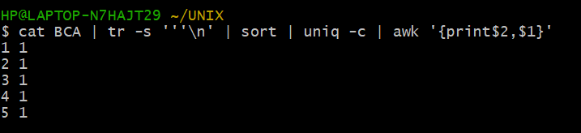

33. Move to "Web" Directory

* ANS:

$ cd ASP

$ cd Web

* OUTPUT:

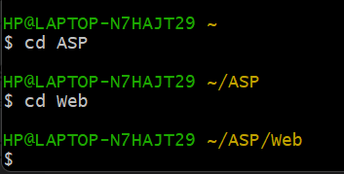

34. Translate "Intro" file into "Upper case".

* ANS:

$ tr [a-z] [A-Z] < intro.txt

* OUTPUT:

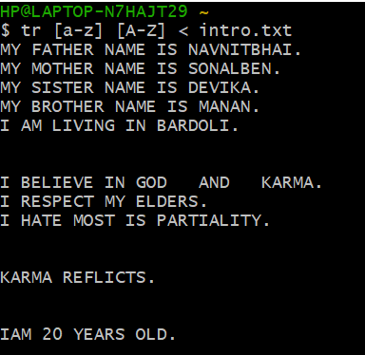

35. Translate "Stud" file with delimiter "-" and print only 3 records.

* ANS:

$ cat stud.txt | tr ‘,-‘ ‘-‘ | head -3

* OUTPUT:

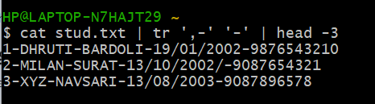

36. Delete vowel from "Intro" files.

* ANS:

$ tr -d [a,e,i,o,u] < intro.txt

* OUTPUT:

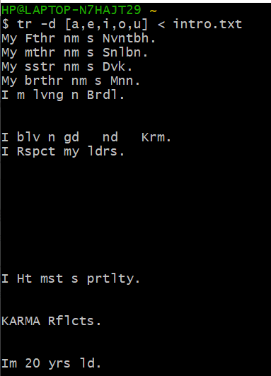

37. Remove all leading spaces from file "Into".

* ANS:

$ tr -s “ “ < intro.txt

* OUTPUT:

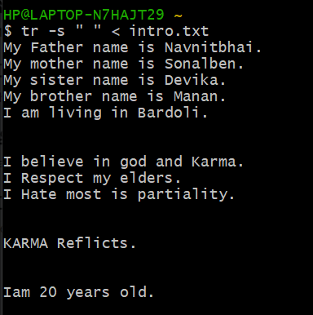

38. To delete all special character in "BCA" file.

* ANS:

$ cat BCA | tr -d ‘||’

* OUTPUT:

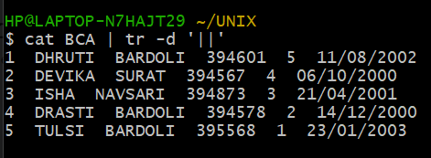

39. Replace multiple space between two words with single space.

* ANS:

$ cat ibtro.txt | tr -s “ “

* OUTPUT:

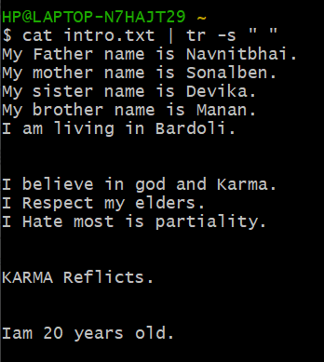

40. Write a command to sort a line of "BCA" file and remove repeated lines.

* ANS:

$ cat BCA | uniq

* OUTPUT:

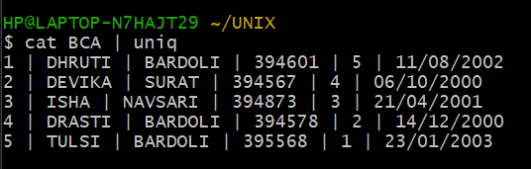

41. Replace all occurance of "Bardoli" with "Baroda" in"BBA".

* ANS:

$ tr “BARDOLI” “BARODA” < BBA

* OUTPUT:

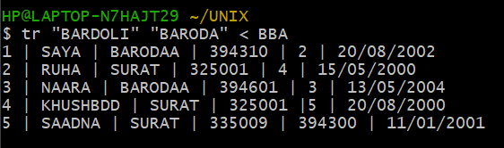

42. Replace all occurance of "Bardoli" with "Baroda" in 5th line of "BCA"

* ANS:

$ head -5 BCA tail +5 | tr “BARDOLI” “BARODA”

* OUTPUT:

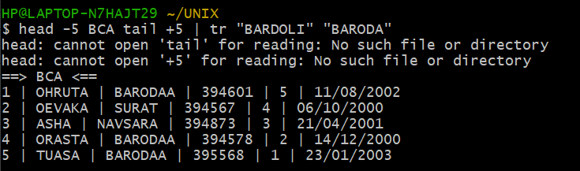

43. Count all occurance of "My" in "Intro" file

* ANS:

$ cut -f 1 intro.txt | grep -i “My” | wc -l

* OUTPUT:

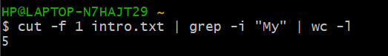

44. To Count the number of words in line 5 to line 10 of file "Intro".

* ANS:

$ head -10 intro.txt | tail +5 | wc -c

* OUTPUT:

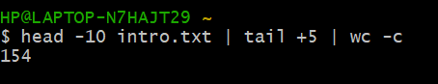

45.To move all files begin with digit from parent directory to the current directory.

* ANS:

$

* OUTPUT: